Course Management system (Full stack)

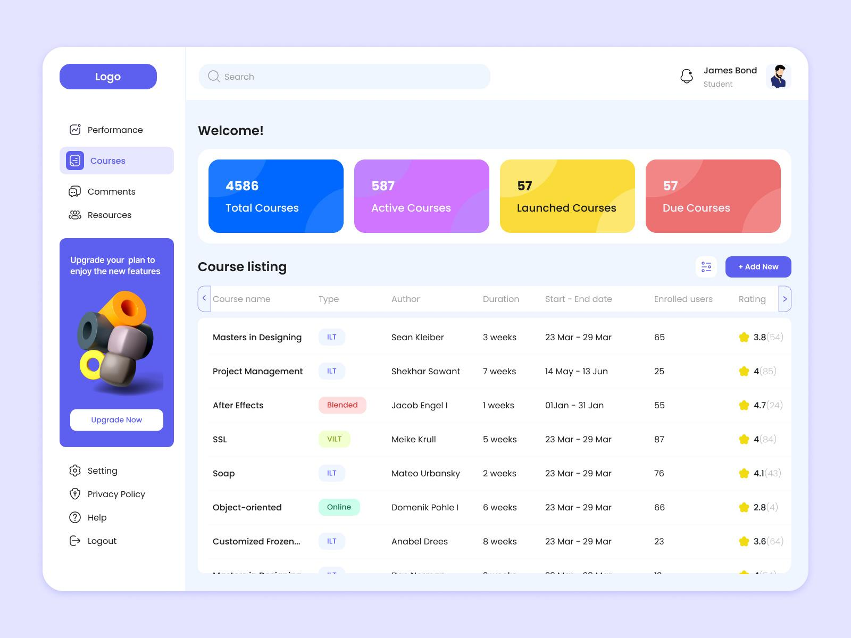
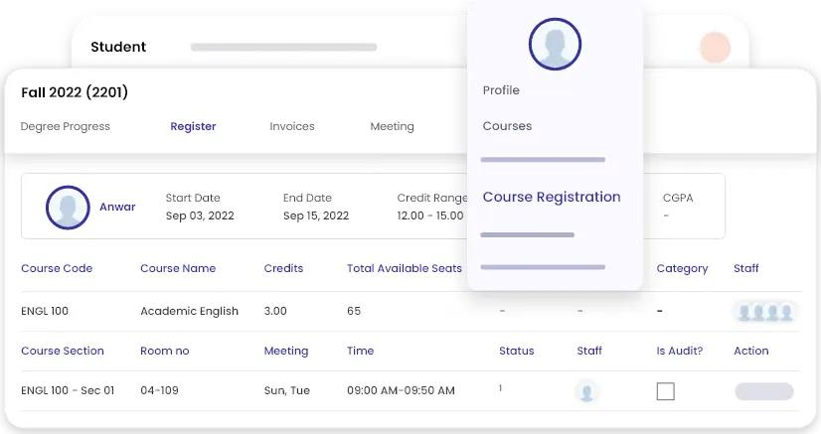

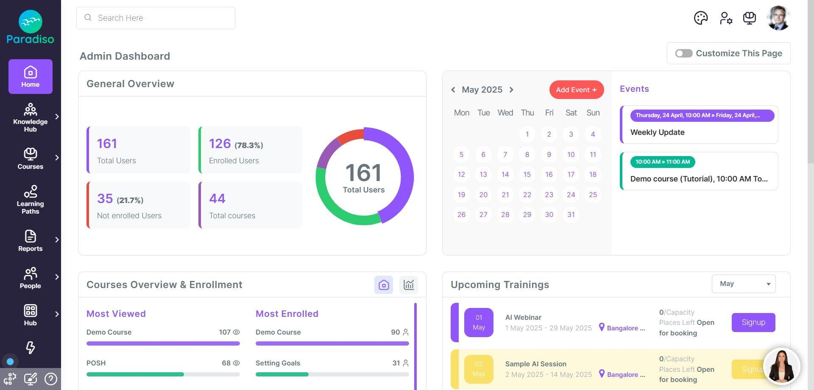

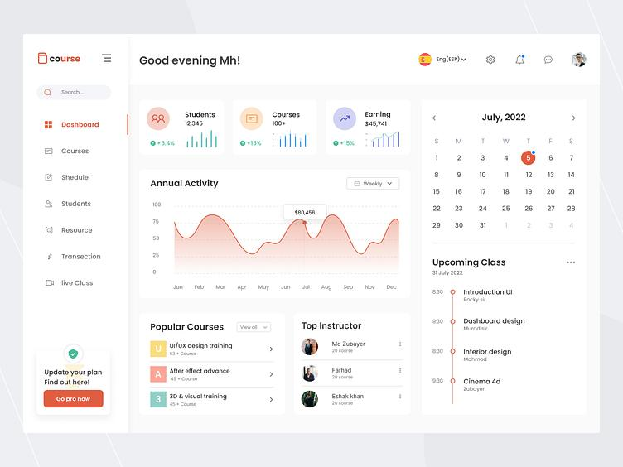

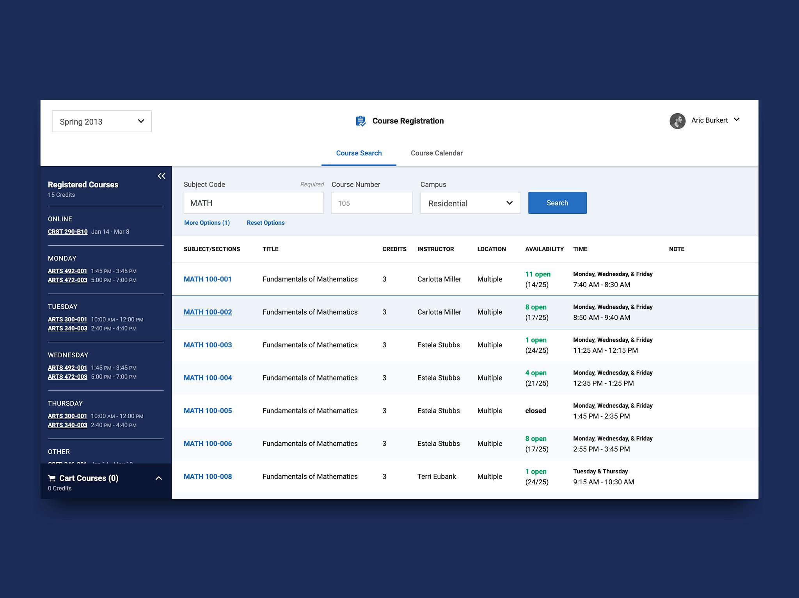

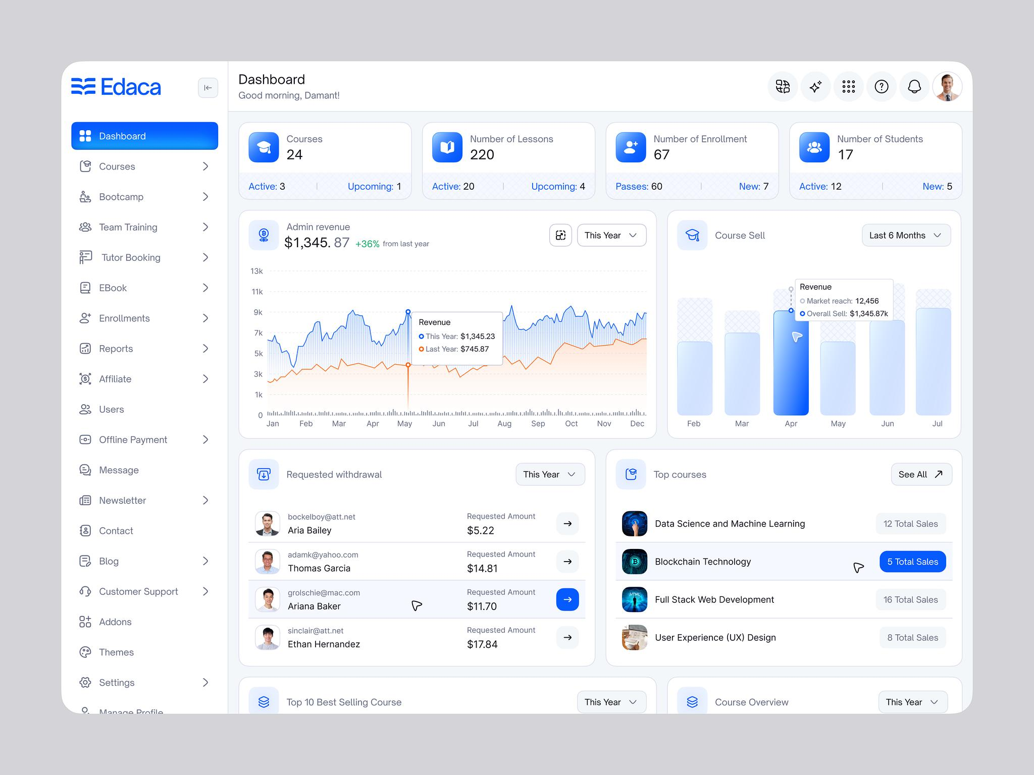
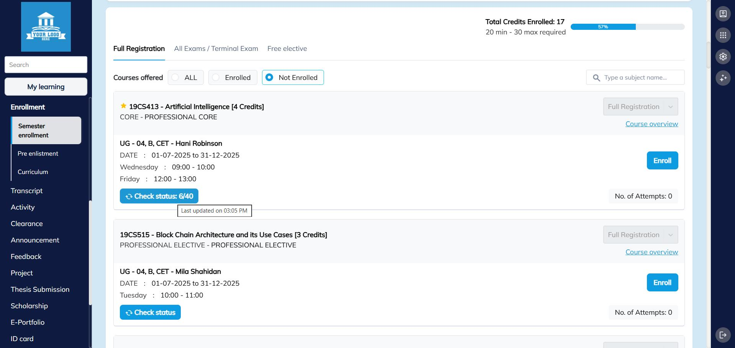
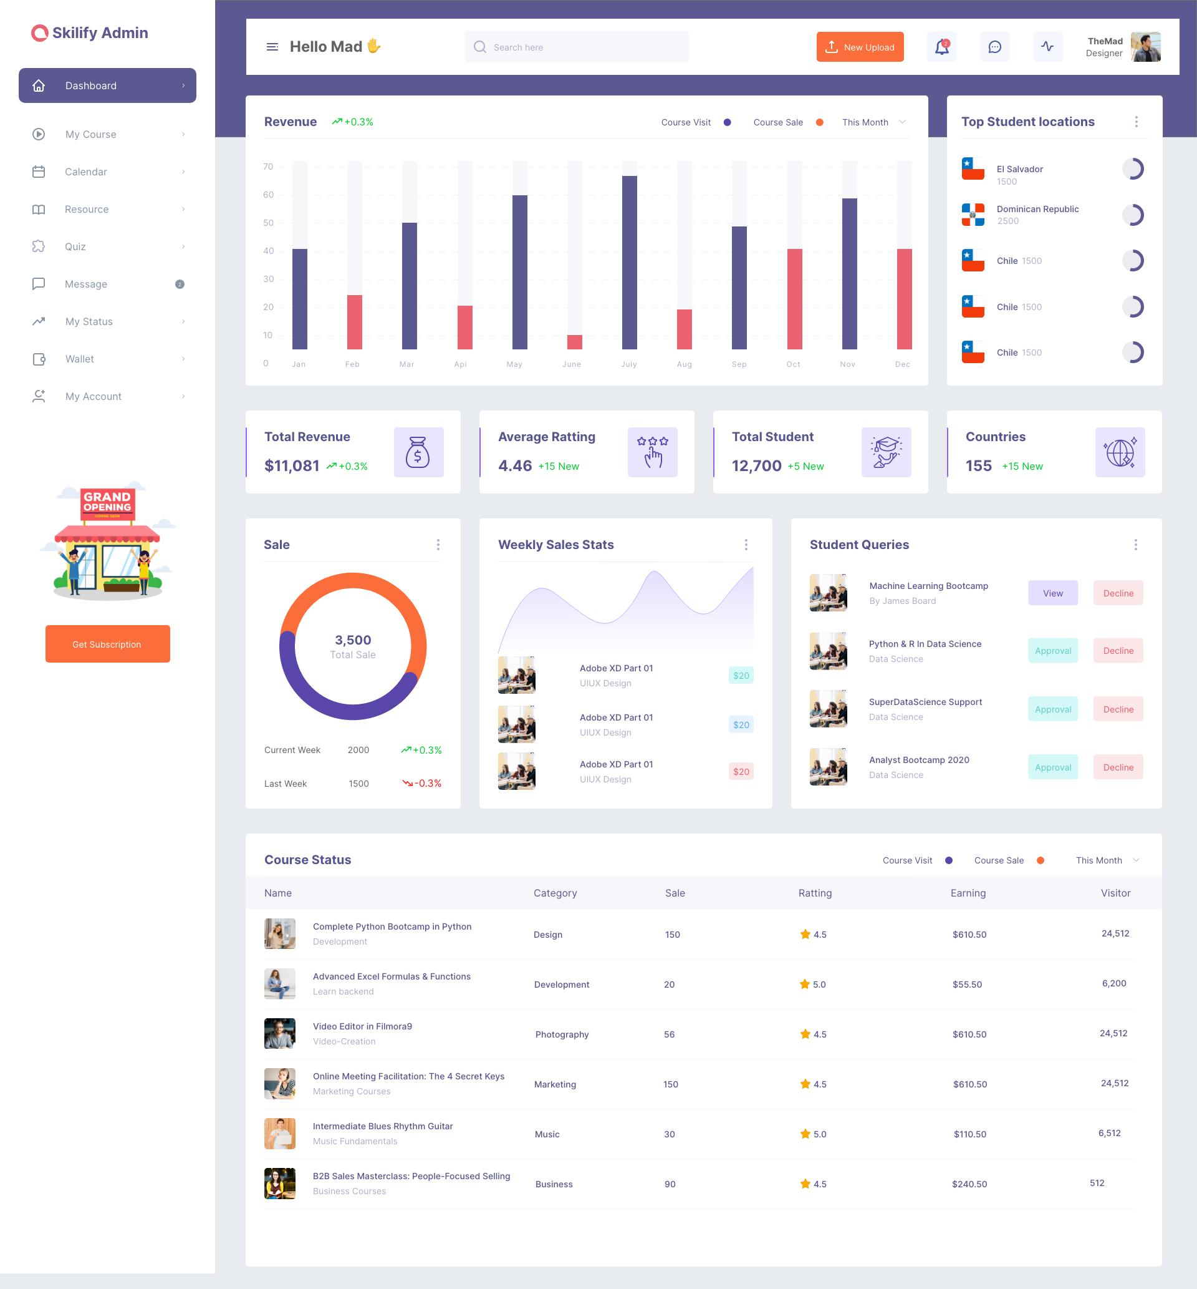

ERD Digram:

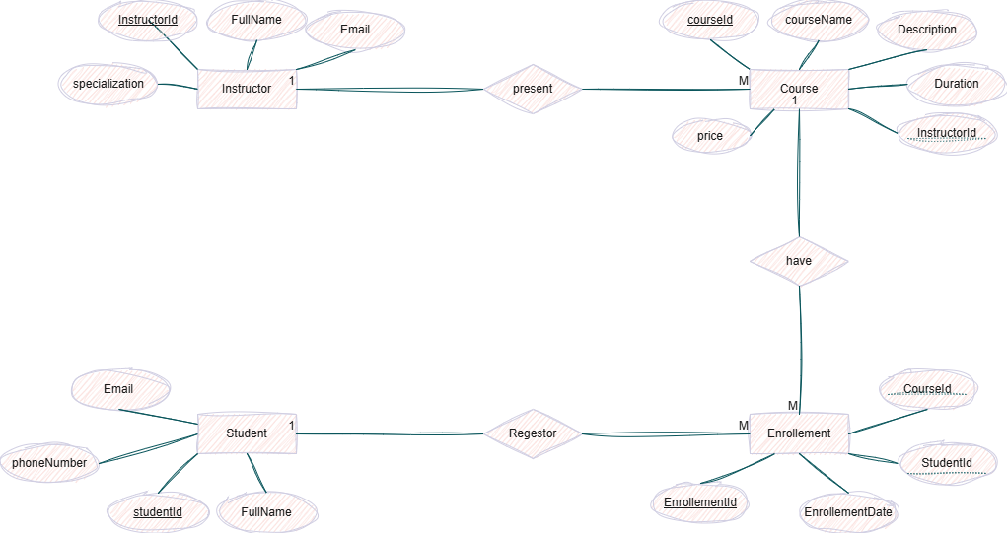

3. Models :
5 Models :
👤 User
Roles:
- Admin
- Instructor
- Student
👨‍🏫 Instructor
📚 Course
👨‍🎓 Student
📝 Enrollment

4. The most important functions of the system :

👑 Admin:
- Login
- Register User
- View Users
- Add Instructor
- Update Instructor
- Delete Instructor

- Add Course
- Update Course
- Delete Course

- View Students
- View Enrollments

👨‍🏫 Instructor:
- Login
- View My Courses
- View Students
- View Enrollments
- Add Grades
- Update Grades

👨‍🎓 Student:
- Register
- Login
- View Courses
- Search Courses
- View Course Details
- Enroll in Course
- View My Courses
- View Grades
- Drop Course

5. Backend Structure:
Course Management System
1. Controllers:
- AuthController.cs
- CourseController.cs
- StudentController.cs
- InstructorController.cs
- EnrollmentController.cs

2.Models
- User.cs
- Student.cs
- Instructor.cs
- Course.cs
- Enrollment.cs

3.DTOs
- LoginDto.cs
- RegisterDto.cs
- CourseDto.cs
- EnrollmentDto.cs

4.Data
- CourseContext.cs

5.Repositories
- CourseRepository.cs
- StudentRepository.cs
- EnrollmentRepository.cs

6. Services
- CourseService.cs
- StudentService.cs
- EnrollmentService.cs

7.Migrations
- Program.cs
- appsettings.json

6. Frontend Angular
course-management-frontend
│
├── src
│ └── app
│ │
│ ├── components
│ │ ├── login
│ │ ├── register
│ │ ├── navbar
│ │ └── dashboard
│ │
│ ├── pages
│ │ ├── courses
│ │ ├── course-details
│ │ ├── my-courses
│ │ ├── students
│ │ └── instructors
│ │
│ ├── services
│ │ ├── auth.service.ts
│ │ ├── course.service.ts
│ │ ├── student.service.ts
│ │ └── enrollment.service.ts
│ │
│ ├── guards
│ │ └── auth.guard.ts
│ │
│ └── interceptors
│ └── jwt.interceptor.ts

7. API:

Authentication:
POST /api/auth/register
POST /api/auth/login

Courses:
GET /api/course
GET /api/course/{id}
POST /api/course
PUT /api/course/{id}
DELETE /api/course/{id}

Students:
GET /api/student
GET /api/student/{id}
POST /api/student
PUT /api/student/{id}
DELETE /api/student/{id}

Instructors:
GET /api/instructor
GET /api/instructor/{id}
POST /api/instructor
PUT /api/instructor/{id}
DELETE /api/instructor/{id}

Enrollment
POST /api/enrollment
GET /api/enrollment
GET /api/enrollment/student/{studentId}
GET /api/enrollment/course/{courseId}
PUT /api/enrollment/{id}
DELETE /api/enrollment/{id}

Swager:

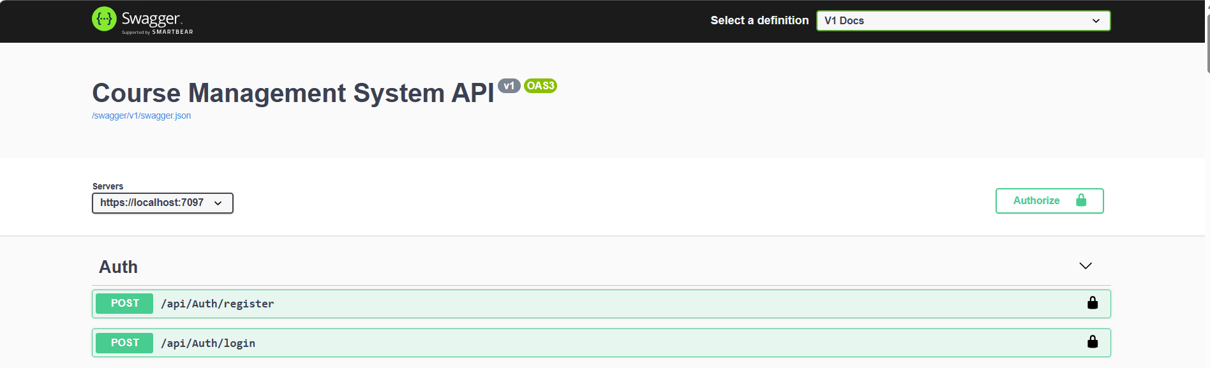

- Enrollment:
- Get:
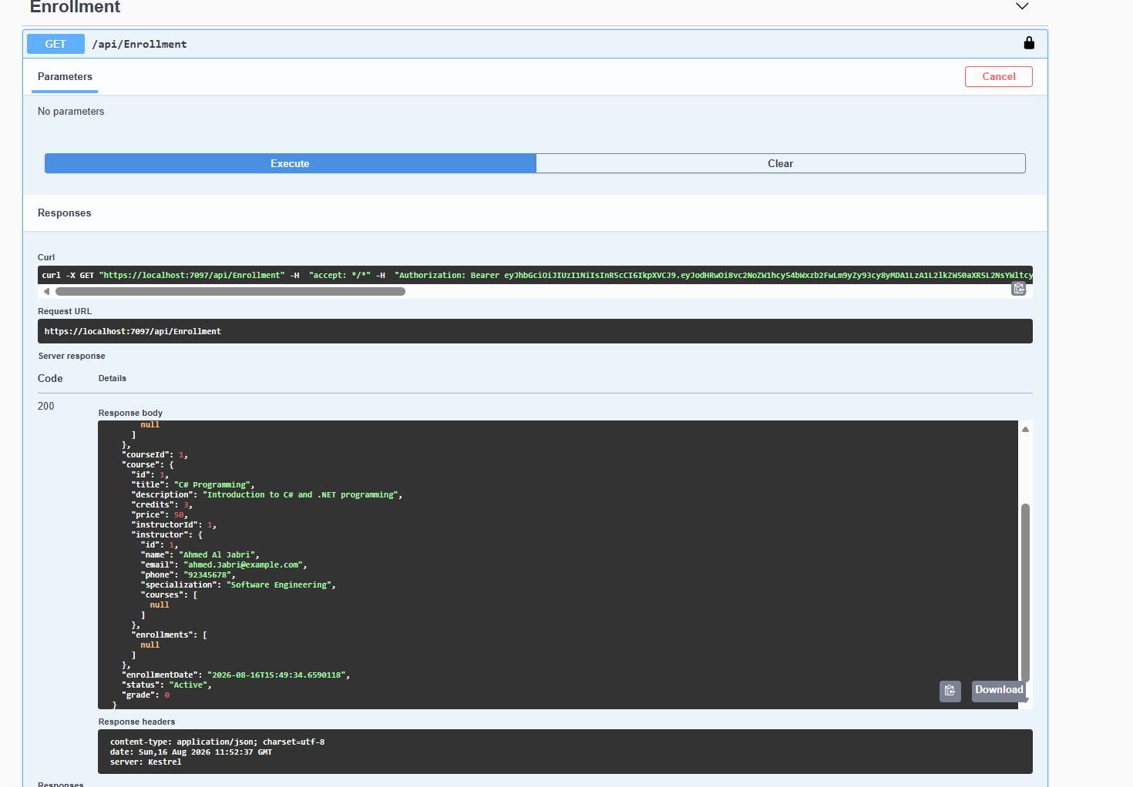
- Post(Add):
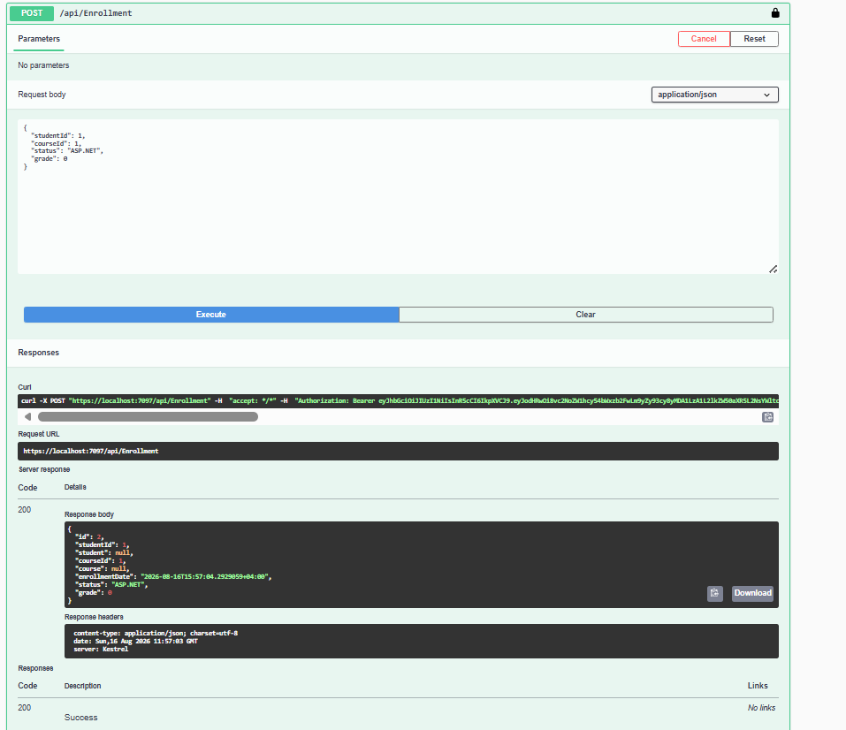

- Get by id:
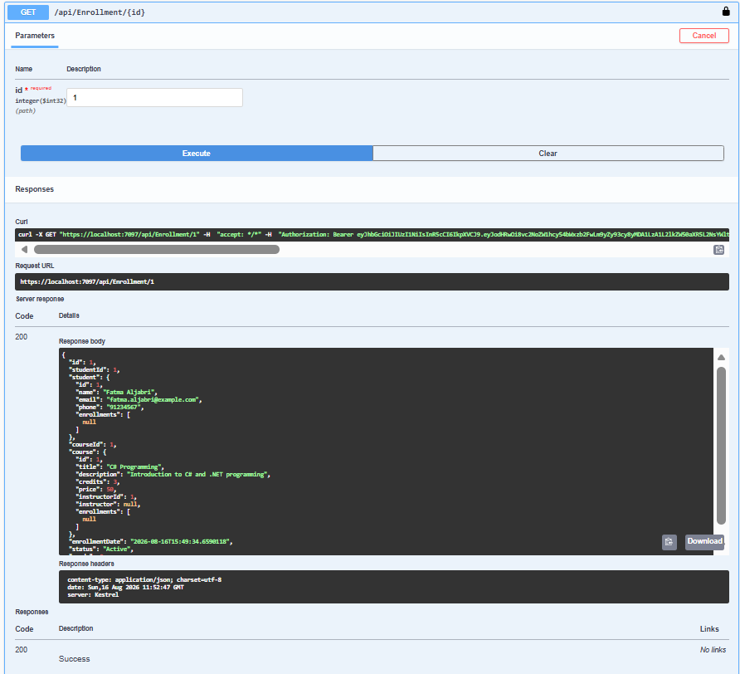

- Update (Put)
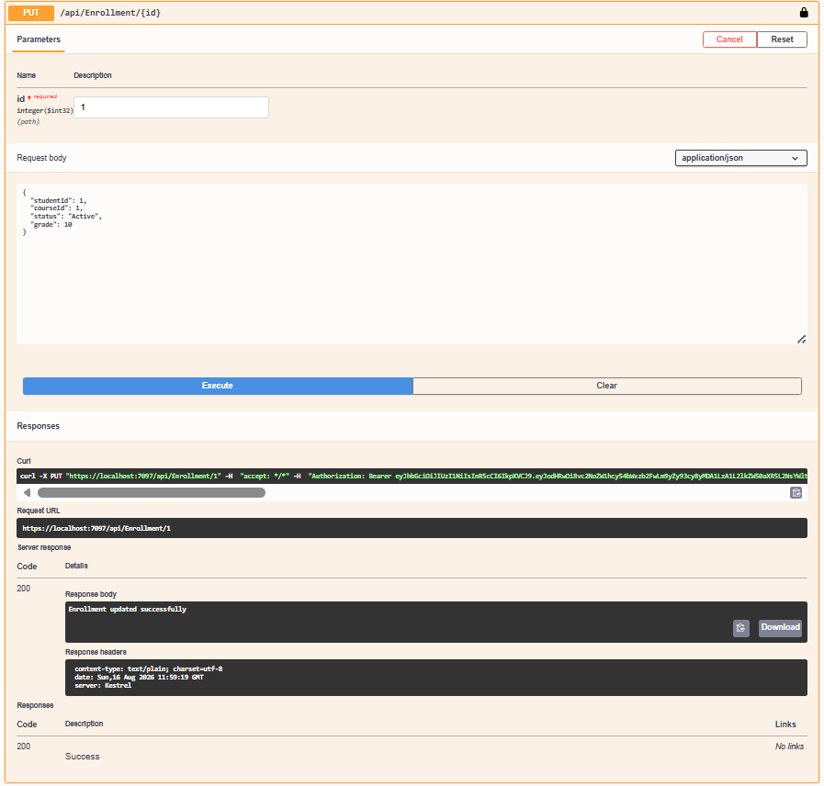

- Get by student id:
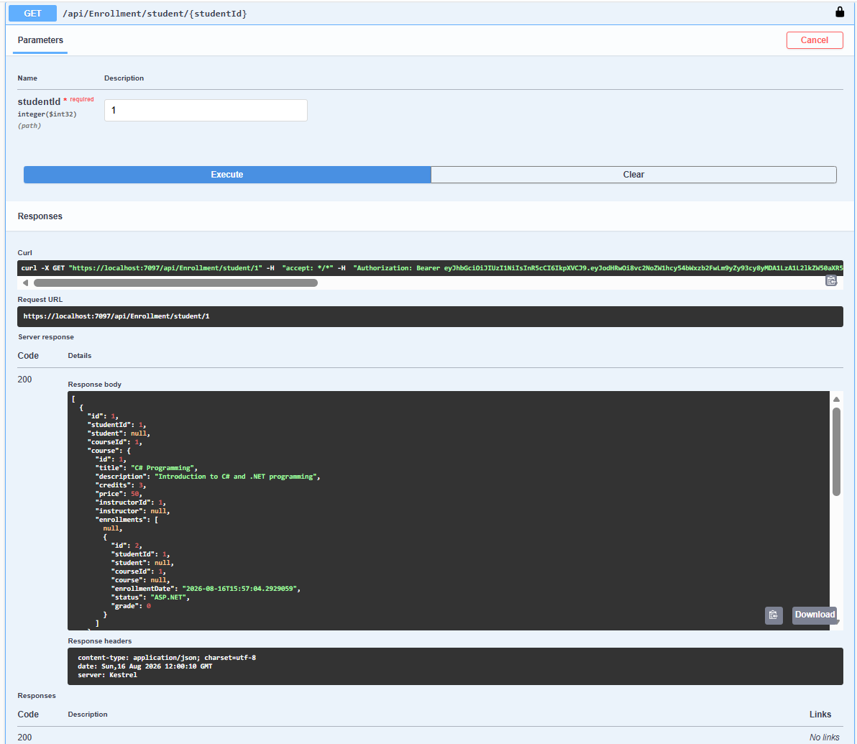

- Get by course id:
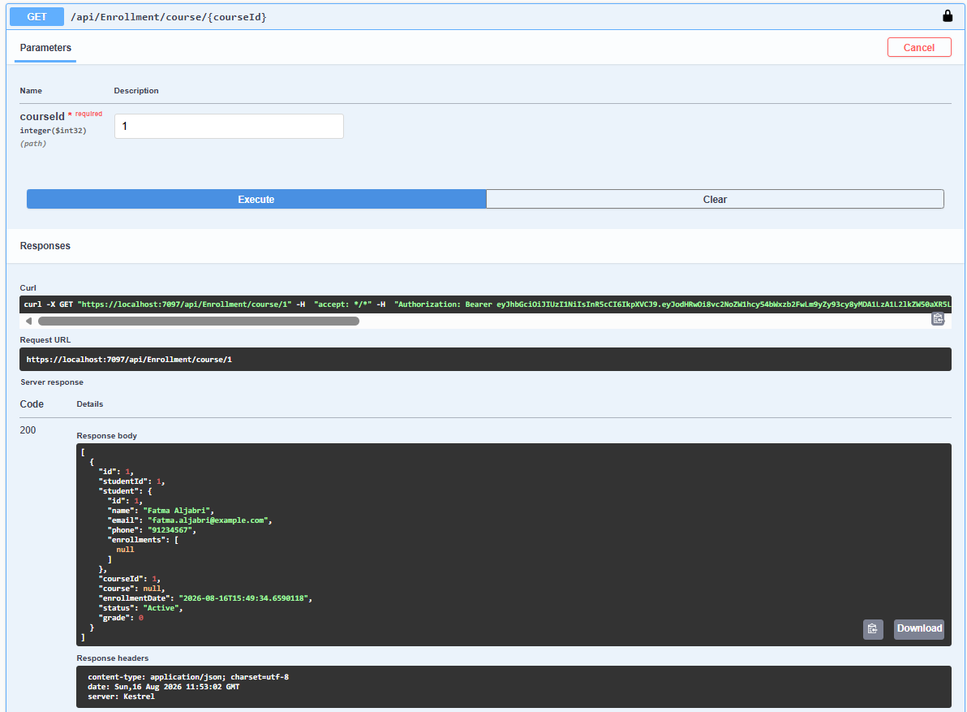

- Instructor:
- Get:
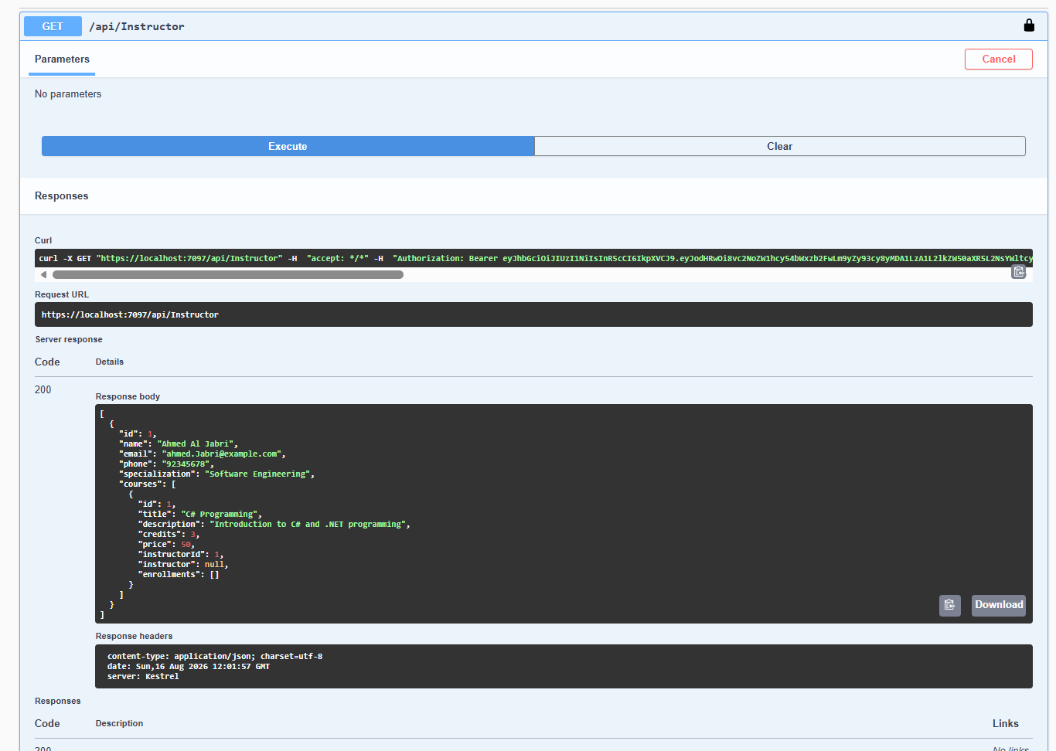

- Post (Add Instructor):
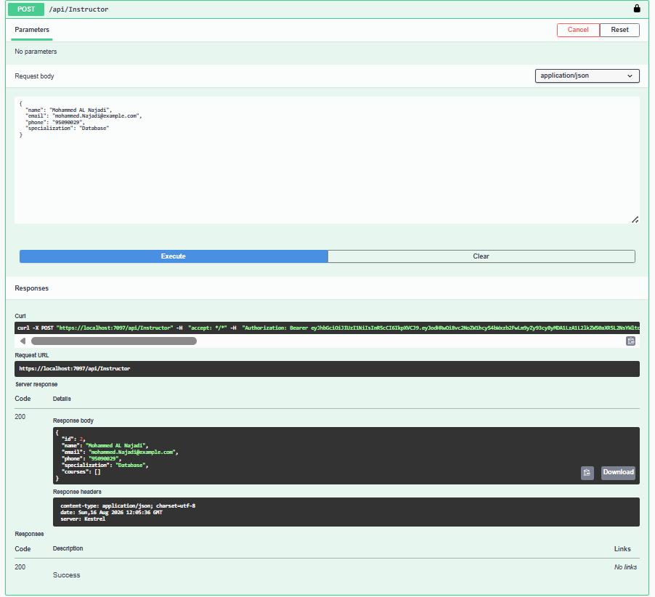

- Get by id:
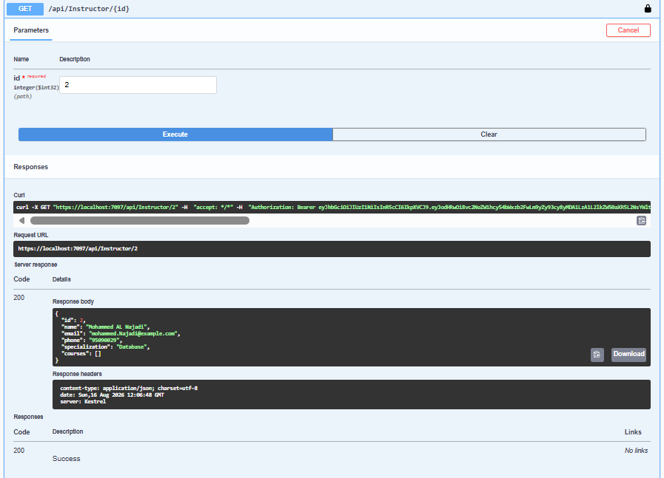

- Update by id (Put):
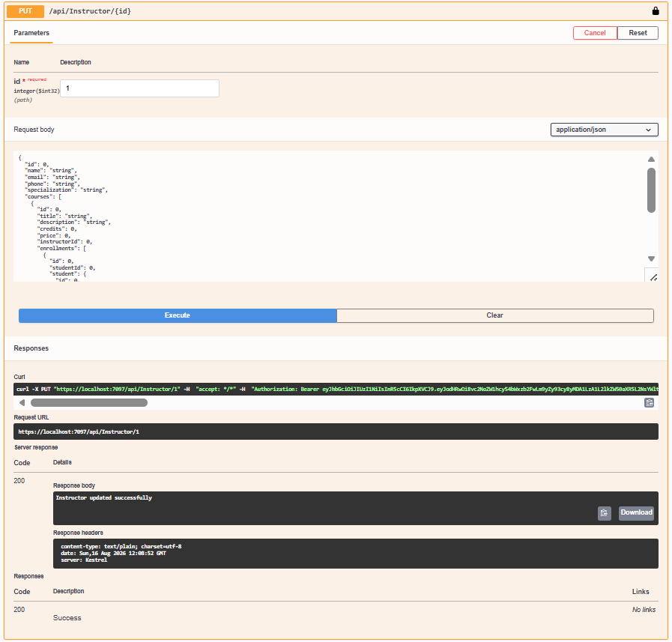

- Delete by id:
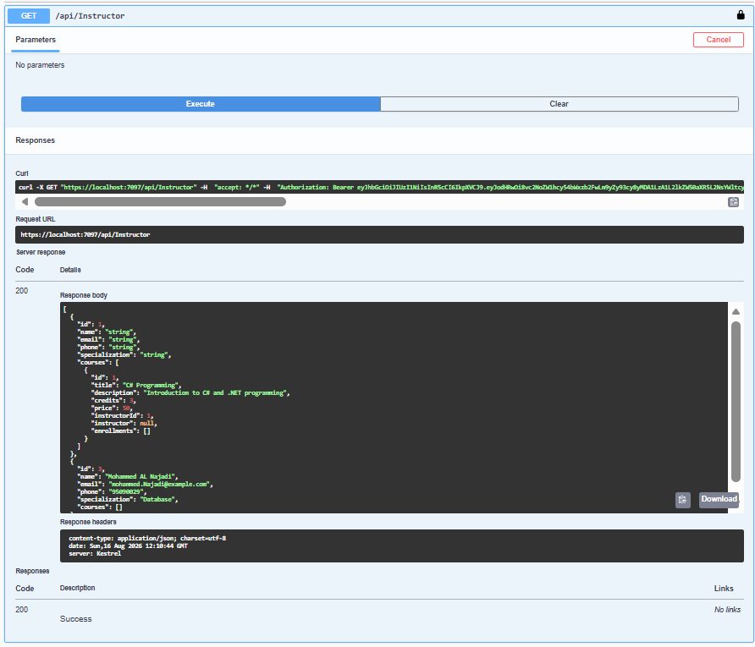
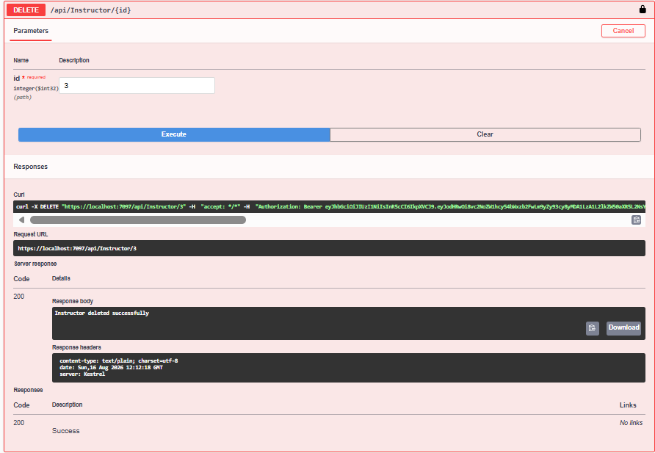

- Course:
- Get:
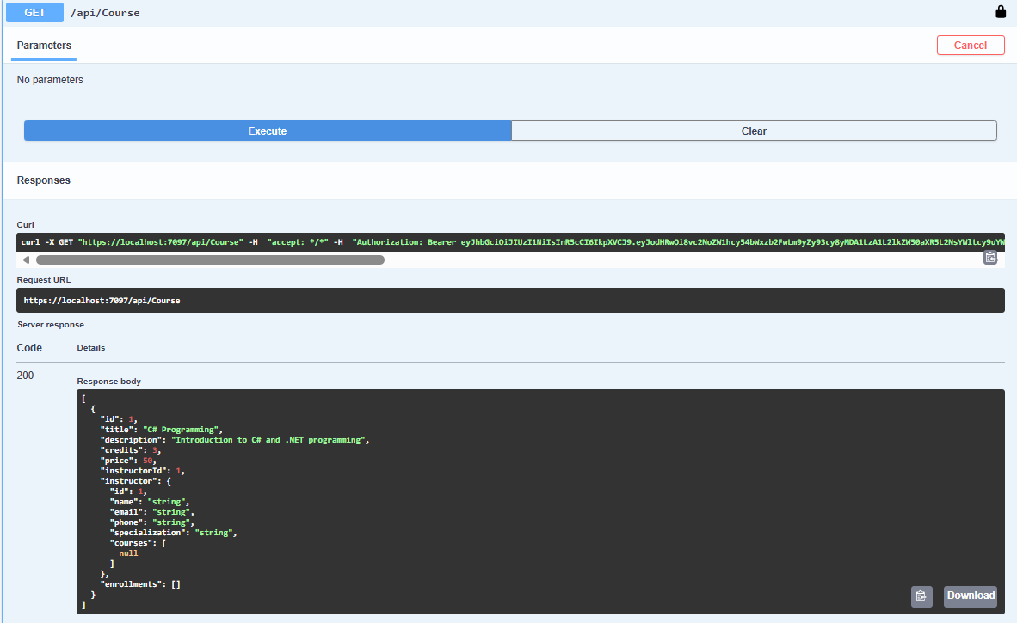

- Post (Add course):

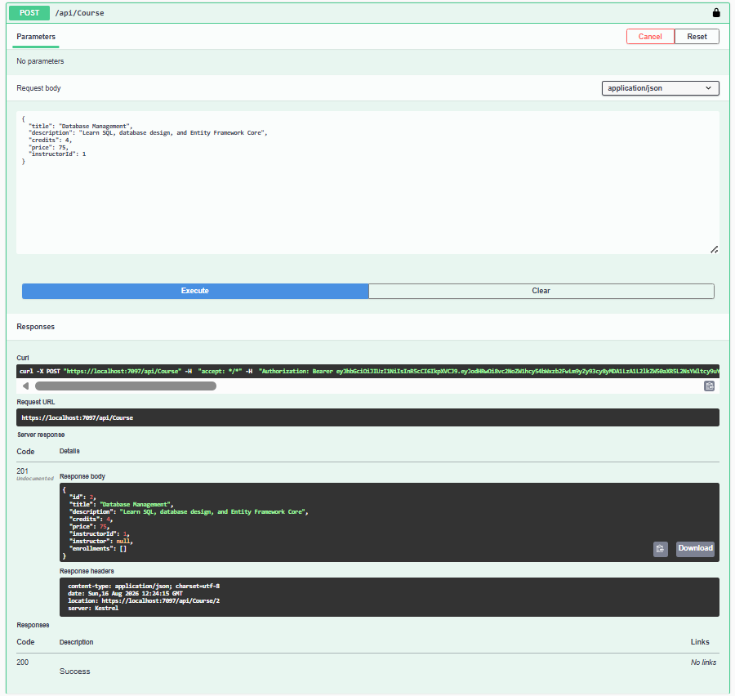

- Get by id:
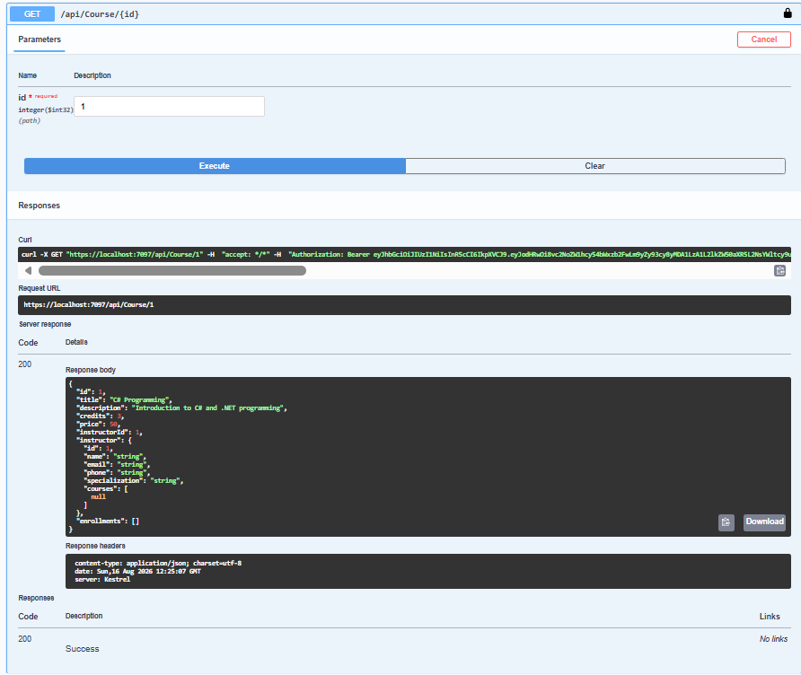

- Put (update):
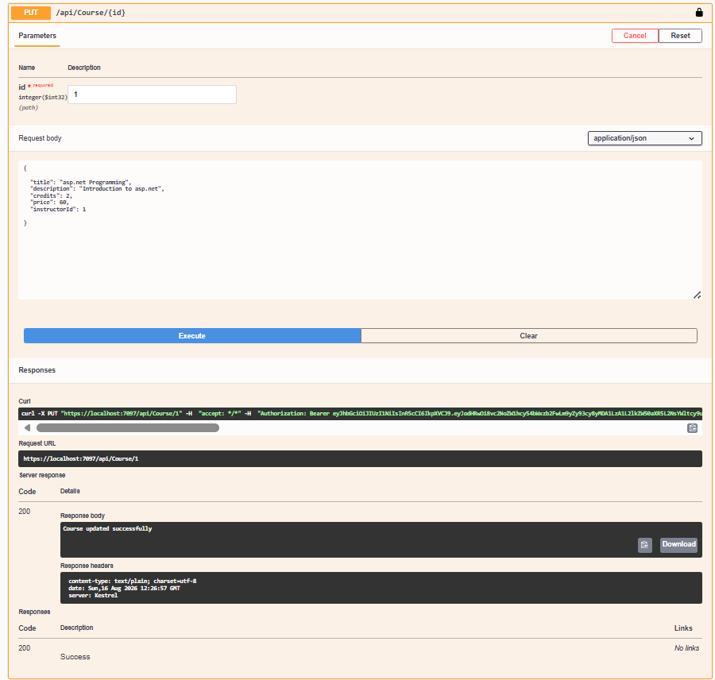

- Delete by id:
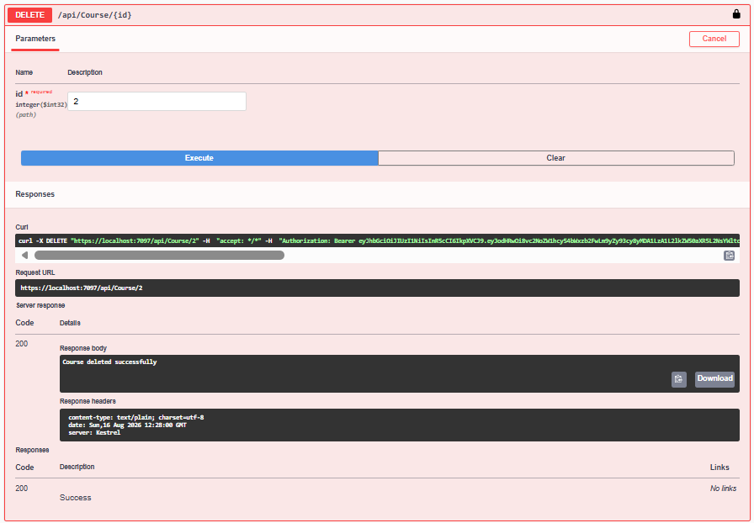

- Student:
- Get:
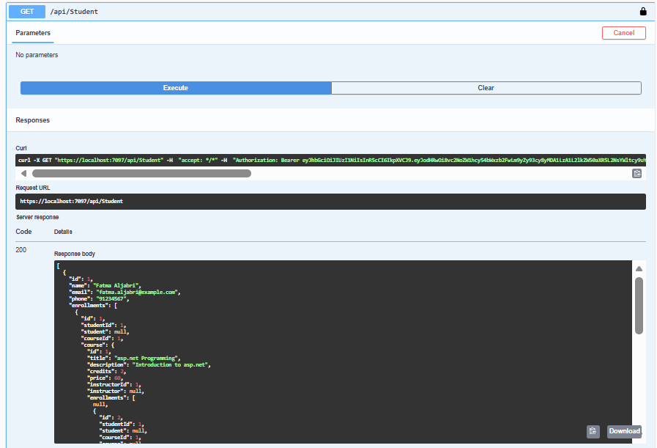

- Post (Add):
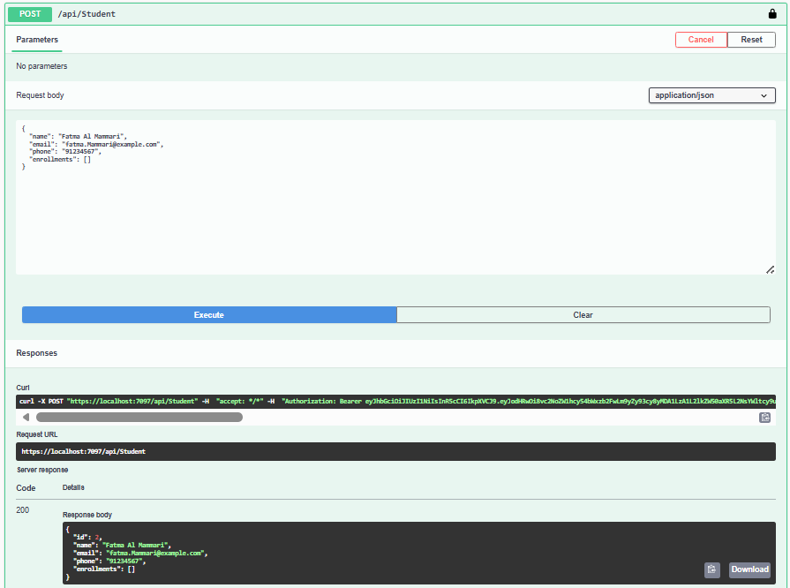

- Get by id:
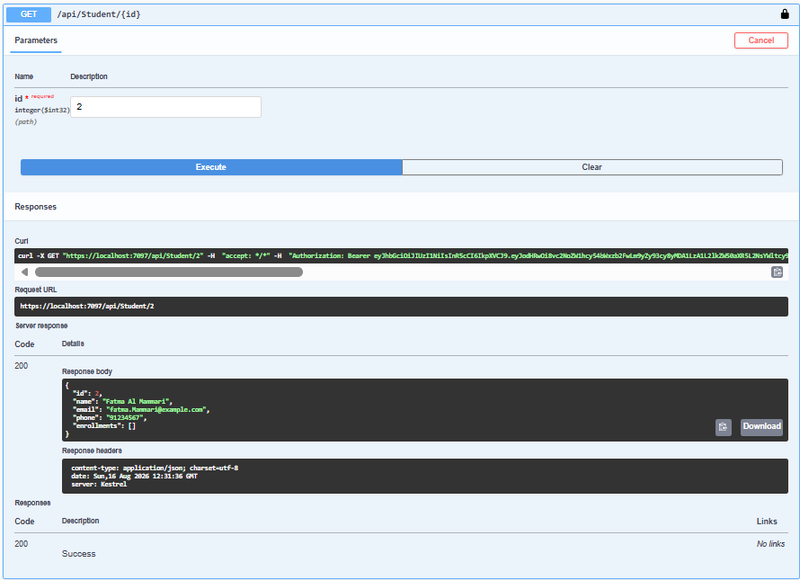

- Put (Update):
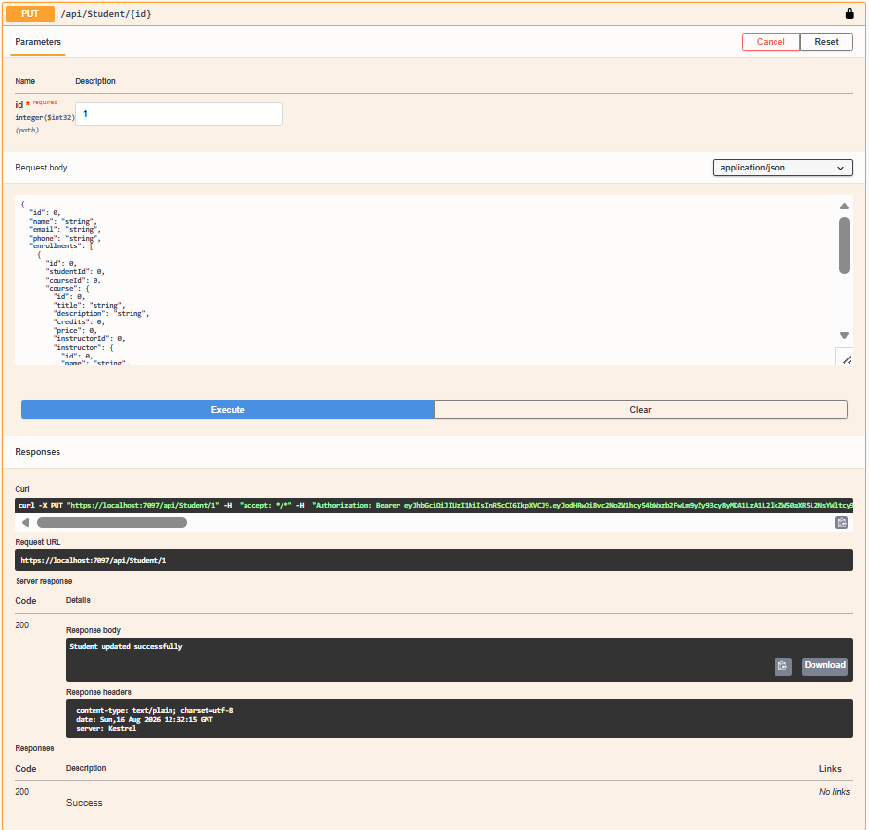

- Delete by id:
